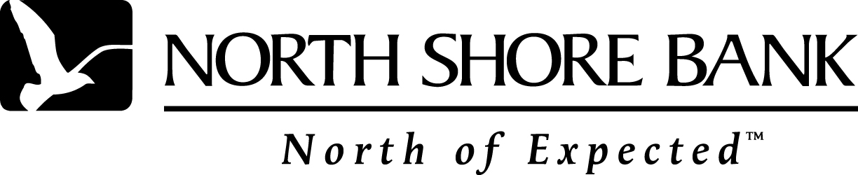

North Shore BANK Expressway
Instant Credit Approval
For New and Used Vehicles

Dealership: ______________________________________________

Customer Name(s): _______________________________________

- All applicants and non-applicant spouses must have a minimum bureau score of 700(Empirica) and a minimum 5-year credit bureau history.
- Full credit reports on both spouses if the lessee is married.
- No co-lessees.
- Minimum verified income of $40,000.
- Bureau report must contain at least 5 trade lines with minimum of 1 vehicle lease/loan. (Qualifying trades exclude utilities and student loans.)
- Current and continuous source of income for a minimum of 5 years (verifiable upon request).
- Bureau report must be free of any bankruptcy, foreclosure, repossession, charge-off, unpaid collections, unpaid tax liens, pending or unpaid lawsuits or current delinquencies.
- Lease must be for personal use only. No business leases allowed.
- Must be Wisconsin resident and vehicle must be titled and used in Wisconsin.
- New vehicles: Maximum Advance is 100% of MSRP with a maximum of $40,000.
- Used vehicles: Maximum Advance is 100% of CRV with a maximum of $40,000
- Terms available 24 – 60 months.
- Attach completed and signed credit application along with a copy of scored credit bureau.
- Waive security deposit at no cost
- Free deferred 1st payment and $100 discounted Acquisition fee

Please consult your North Shore Bank Lease Manual for further details on our lease program guidelines, rules and enhancements.

Any questions regarding North Shore Bank Expressway Instant Credit Approval, please contact your Regional Account Manager.

Thank you for using North Shore Bank!
(expresswaydoc) Effective Nov 1, 2003

